**COURSE - IT-WORKSHOPⅠ**

**COURSE :- IT-WORKSHOPⅠ**

**PYTHON PROJECT REPORT**

* **Project Name :- Play Py**
* **Project Theme :-**
* A combination of 4 Games , in which the player will have to choose a Game to play.
* Player’s scores results will be recorded And scoreboard of highest scorers will also be displayed if player wants to see the score after the Game Play for that particular Game.
* **Libraries Used :-**
* **PYGAME :-** for making the graphical user interface and creating responsive mouse clicks and buttons in *GUI* window for both *Alien Invasion* and *Sudoku* game.
* **NUMPY :-** for storing S*udoku* Game and retrieve its values efficiently.
* **REQUESTS :-** for making *API* call to a server to get a fresh grid of unsolved *Sudoku* ,everytime player choose to play *Sudoku*.
* 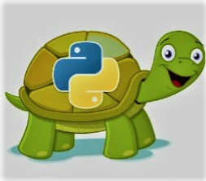**TURTLE :-** for creating pictures and shapes for both *Pacman* and *Snake Game*, using its virtual canvas.

|  |  |  |
| --- | --- | --- |
| S. No. | Games | Libraries Used In Games |
| (1.) | **Alien Invasion** | **PyGame** |
| (2.) | **Pacman** | **TURTLE** |
| (3.) | **Snake Game** | **TURTLE** |
| (4.) | **Sudoku** | **PyGame ,REQUESTS,NumPy** |

* **RESULTS AND PLOTS :-**
* **SNAKE GAME :-**

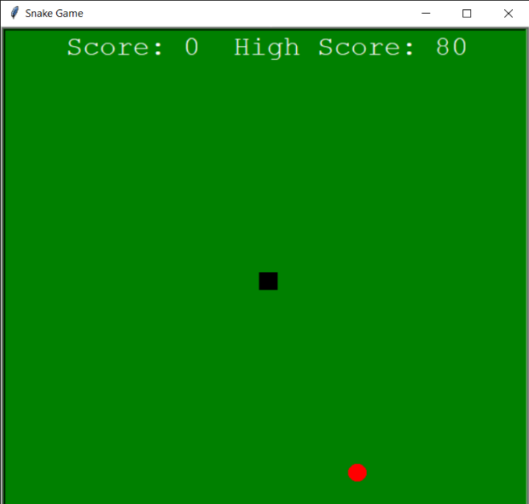

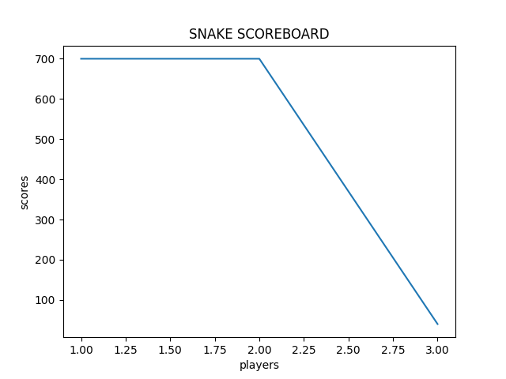

* 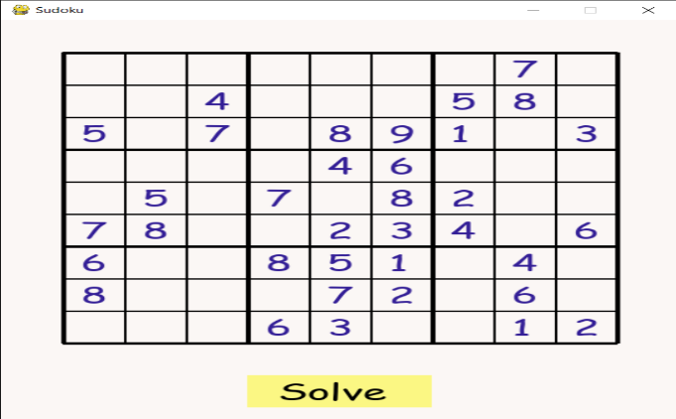**SUDOKU :-**

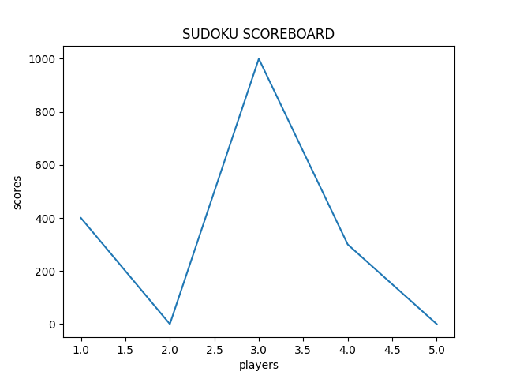

* **PACMAN :-**

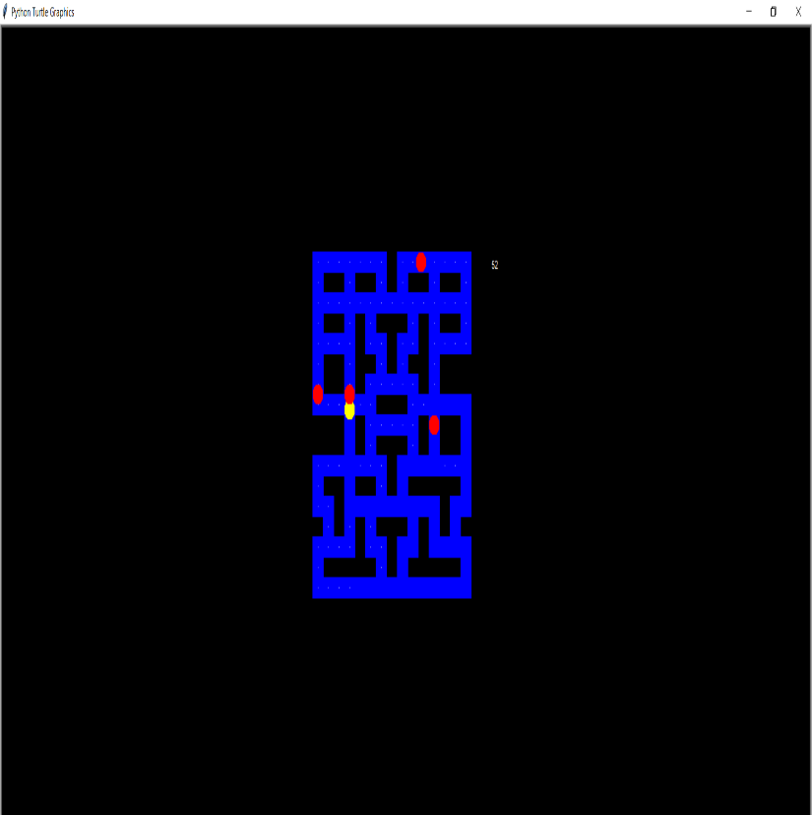

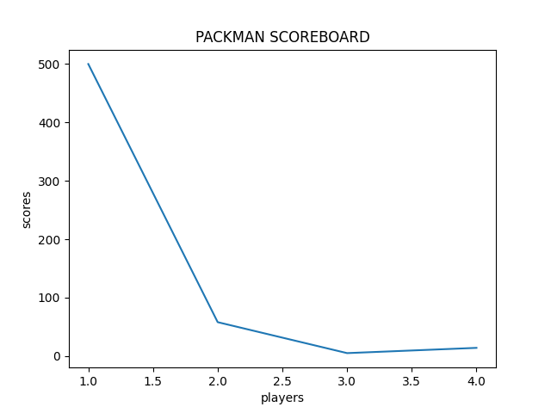

* 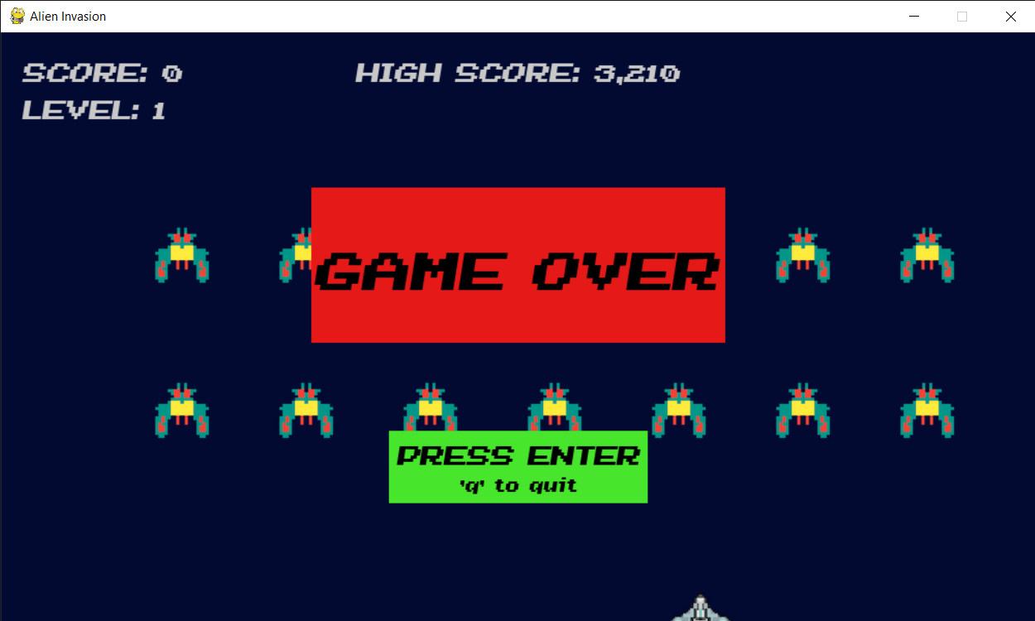**ALIEN INVASION** :-

